Task 1

Sample1.py
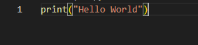
Output
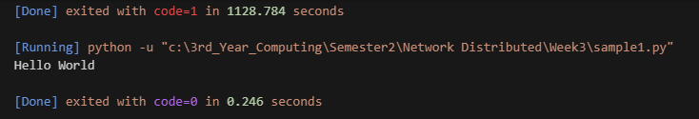

Sample2.py
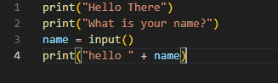
Output
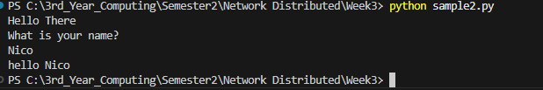

Sample3.py
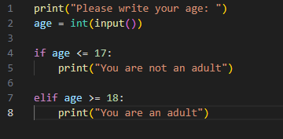
Output
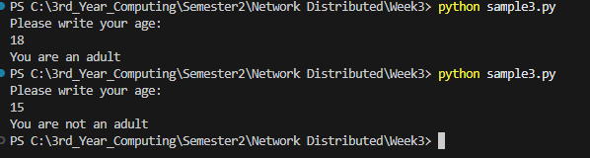
Sample4.py
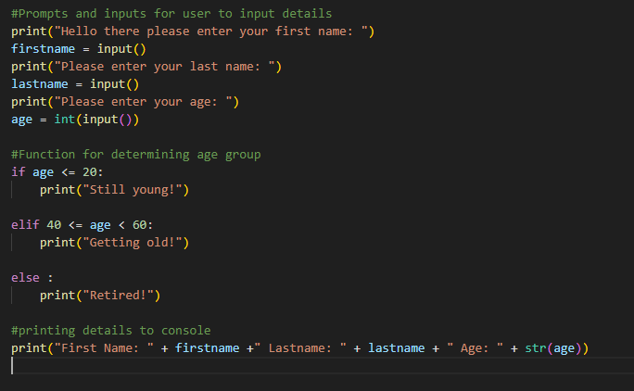
Output
